Contents

Figure Appendix 3

Table Appendix 4

Chapter 1 5

Introduction 5

1.1 Introduction 5

1.2 Challenges for pedestrian attribute recognition 5

1.3 Contributions of this paper 6

Chapter 2 Literature Review 8

2.1 Regular Neural Network 8

2.2 Convolutional Neural Network 9

2.3 Existing works on pedestrian attribute detection: 11

2.4 Pros and Cons of Convolutional Neural Network 14

2.5 Existing Methodologies to be compared to Proposed Network 14

Chapter 3 Methodology 17

3.1 Multi Label Classification 17

3.2 Multi Label Classification problem transformation 17

3.3 Data Preprocessing 17

3.3.1 PETA dataset 17

3.3.2 Downloaded Files Information 19

3.3.3 Label and Image Files Preprocessing: 19

3.3.4 Image Preprocessing: 21

3.4 Proposed CNN Model 21

3.5 Classification Loss Function 24

3.6 Optimization Algorithm 25

Chapter 4 Experiments and Results 28

4.1 Dataset and experimental settings 28

4.2 Experimental Tools and Environment 28

4.2.1 Programming Language 28

4.2.2 Integrated Development Environments 29

4.2.3 Libraries 29

4.3 Implementation Details 30

4.4 Performance Evaluation metric 30

4.5 Experimental Results 31

4.6 Discussion 39

4.6.1 Model Results for 47 attributes 40

4.6.2 Model results for 35 attributes and comparison 41

Chapter 5 Conclusion and Future Work 42

5.1 Conclusion 42

5.2 Future Work 42

References 43

# Figure Appendix

Figure 1 Main categories of pedestrian attributes to be detected from far view pedestrian images 7

Figure 2 Structure of a perceptron 8

Figure 3 Neural networks with fully connected layers 9

Figure 4 LeNet architecture[11] 9

Figure 5 AlexNet architecture [12] 10

Figure 6 DeepSAR and DeepMAR model 15

Figure 7 ShallowMAR best model 16

Figure 8 Binary Relevance technique 17

Figure 9 Sample Images from 10 datasets that form PETA dataset 18

Figure 10 Selected pedestrian attribute categories and subcategories 20

Figure 11 Proposed convolutional neural network model architecture 22

Figure 12 Cross entropy loss curve 24

Figure 13 Loss function curve for Learning rate 0.05 32

Figure 14 Loss function curve for Learning rate 0.005 32

Figure 15 Loss function curve for Learning rate 0.0005 33

Figure 16 Loss function curve for Learning rate 0.00005 33

Figure 17 Bar Graph for mean accuracy per attribute for proposed Model 35

Figure 18 Comparison of accuracies per attribute of different models 37

Figure 19 Some samples of images with correct identification of every attributes 38

Figure 20 Some samples with the most incorrect identification of attributes 39

Figure 21 Convolved images for 16 filters after first conv layer 39

Figure 22 Convolved images for 64 filters after final conv layer 40

# Table Appendix

Table 1: Test accuracy score for different fully connected layer architectures 31

Table 2: Attribute recognition accuracy score per attribute of proposed model for 47 attributes 34

Table 3: Attribute recognition accuracy score of proposed model for 35 selected attributes and comparison with DeepMAR and MRFr2 36

Table 4: Average Test Accuracy score for proposed model and other comparison models 38

Table 5: Accuracies for conventional filter sizes for 3rd layer 38

# Chapter 1

# Introduction

## Introduction

Visual recognition and identification of pedestrian attributes has become a very challenging research topic in the domain of intelligence and visual surveillance scenarios which lies within computer vision research. The ability to recognize pedestrian attributes like gender, age, clothing type, footwear type and others at far distance is very significant as face and close body shots are unavailable. In real world surveillance scenarios, the cameras are only able to take wide area shots and they are of very low resolution. So high quality face image is very hard to attain. In the absence of critical face and close body visual information, it is very hard to acquire meaningful information about a pedestrian from an image without analyzing the full body appearance and recognize the pedestrian attributes.

Pedestrian attributes can be used for a lot of applications like

* Person retrieval
* Person re-identification
* Tracking by detection
* Querying databases by semantic propositions
* Robotic applications that require semantic information of persons for interactions.

The problem of recognizing pedestrian attributes is determining the attributes correctly by using full body images.

## Challenges for pedestrian attribute recognition

Variety of fundamental challenges stand in the way of recognizing pedestrian attributes. Some of them are -

1. **Diversity of pedestrian clothing and accessories**: This makes it very challenging to correctly identify important attributes of the body
2. **Various Illumination Conditions and Different camera view angle**: Owing to these variation and the diversity of pedestrian clothing, intra class variation occurs among different images for same attribute.
3. **Complex Localizing Characteristics**: Some attributes can only be localized at some certain or uncertain local body areas. As a result pedestrian attribute feature extraction gets very difficult
4. **Ambiguity of appearance**: Far view attribute recognition gets very difficult due to inherent visual ambiguity and poor quality of the visual features extracted from far view images. Often parts of the body gets occluded by obstacles or other pedestrians, which further increases the difficulty of extracting the right features for inference.
5. **Multi-Label classification**: Pedestrian Attribute recognition is a multi-label classification problem rather than a multi class or a single class classification problem. Attributes are not completely mutually exclusive. So, therefore multi class classification algorithms are not applicable and multi-label classification problems already have challenges of their own.

Because of the above challenges in pedestrian attribute recognition from far view images, the traditional hand crafted feature extraction methods[21,22,23,24,25] cannot cope well in real world surveillance scenarios. Features extracted from such method cannot represent the images well enough because of the variations and diversities in surveillance scenarios and their limited representation capability. And also while extracting the features, the relationship between the attributes are ignored. In the past couple of years deep learning models have been seen to outperform the hand crafted feature methods as they can automatically learn features from images and among them, convolutional neural networks have shown incredible performance. They have performed impressively when it came to computer vision tasks such as image classification and recognition. It is because they are composed of several layers, they are able learn from low level features to high level abstract features starting from first to last layer.

## Contributions of this paper

So, we propose a custom convolutional neural network based deep learning model for recognizing multiple attributes at once from far view images. The contributions of our paper are

* Proposes a CNN based model which addresses the pedestrian attribute recognition problem as a multi label classification task and predicts all attributes at once thus working on the relationship between attributes
* Compare performance with the previous CNN based models for pedestrian attribute recognition which also predicted multiple attributes simultaneously and show that the proposed model outperforms them

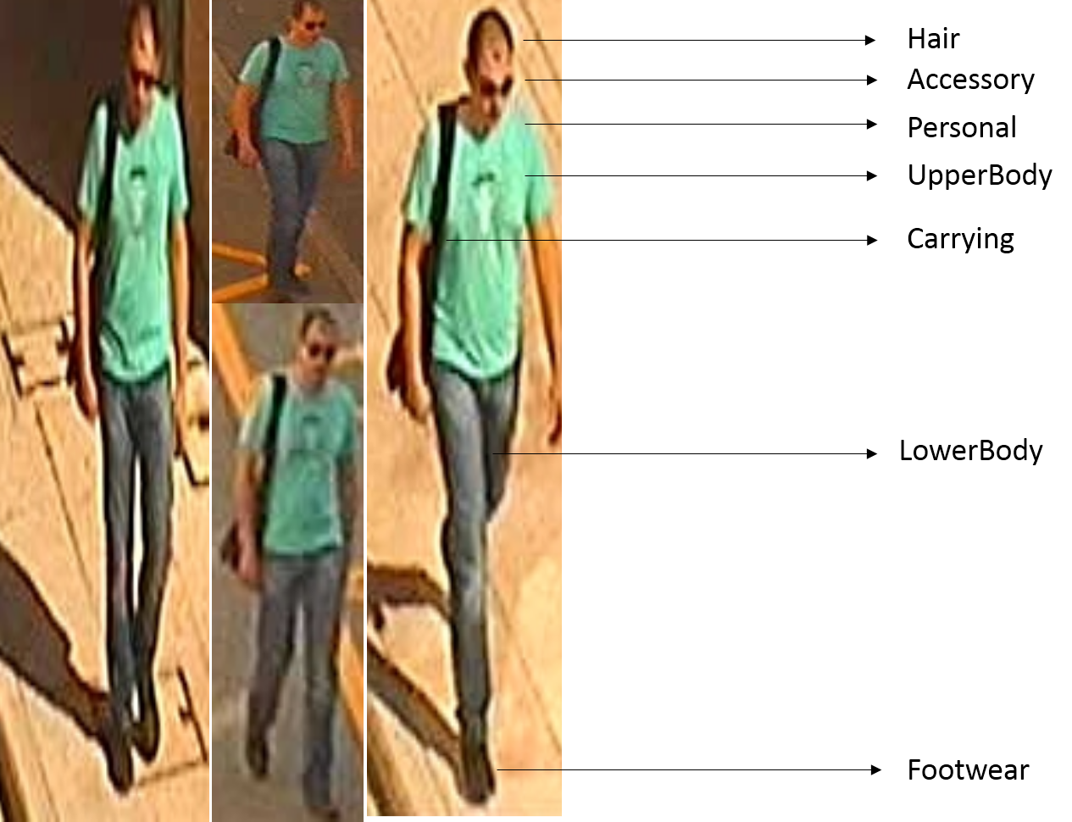

Figure Main categories of pedestrian attributes to be detected from far view pedestrian images

# Chapter 2 Literature Review

Now that we know about the background, objectives and contributions of this paper, we are going to discuss the nature of regular neural networks and convolutional neural networks and why we have decided to use convolutional neural network for this work.

## Regular Neural Network

Artificial Neural networks are deep learning models inspired by the structure and functionalities of the human brain. They learn and make decisions the way a human brain perceives the world and draws conclusions.

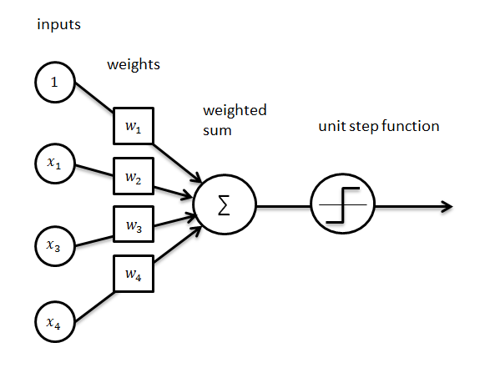

Figure Structure of a perceptron

The above figure shows the structure of a perceptron which is a unit with weighted inputs that produces a binary output based on a threshold.

ANN is a set of connected neurons organized in layers:

* **Input layer:** Brings the initial data into the system for further processing by subsequent layers of artificial neurons.
* **Hidden layer**: A layer in between input layers and output layers, where artificial neurons take in a set of weighted inputs and produce an output through an activation function.
* **Output layer:** The last layer of neurons that produces given outputs for the program.

The following figure shows two neural network structures that use stack of fully connected layers

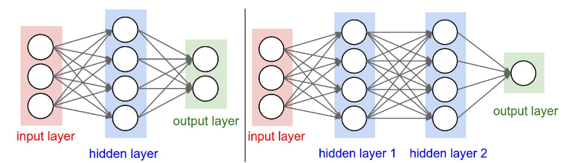

Figure Neural networks with fully connected layers

## Convolutional Neural Network

Convolutional Neural Networks are very similar to ordinary Neural Networks i.e. they are made up of neurons that have learnable weights and biases. In particular, unlike a regular Neural Network, the layers of a ConvNet have neurons arranged in 3 dimensions: width, height, depth.

Convolutional Neural Networks (ConvNets or CNNs) are a category of Neural Networks that have proven very effective in areas such as image recognition and classification. They take advantage of the fact that the input consists of images and they constrain the architecture in a more sensible way. They are effective for analyzing images because –

* They are designed to recognize visual patterns directly from pixel images with minimal preprocessing.
* They are designed to learn the filters that are hand engineered in traditional algorithms
* They can recognize patterns with extreme variability and with robustness to distortions and simple geometric transformations.

LeNet[11] was one of the very first convolutional neural networks which helped propel the field of Deep Learning. This pioneering work by Yann LeCun was named LeNet5 after many previous successful iterations since the year 1988

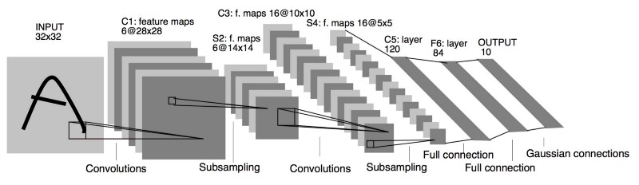

Figure LeNet architecture[11]

2012 was the first year that convolutional neural network grew to prominence as Alex Krizhevsky[12] used them to win that year’s ImageNet competition. AlexNet significantly outperformed all the prior competitors and won the challenge by reducing the top-5 error from 26% to 15.3%. The network had a very similar architecture as LeNet by Yann LeCun et al but was deeper, with more filters per layer, and with stacked convolutional layers.

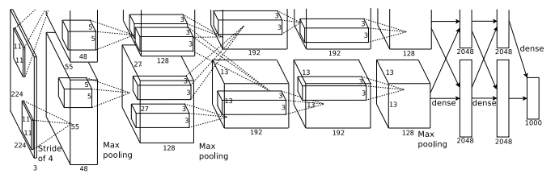

Figure AlexNet architecture [12]

VGG-16[14] convolutional neural network was also very successful for large scale image recognition in 2015.

There are four main operations that occur in a convolutional neural network -

1. **Convolution:** The primary purpose of Convolution in case of a ConvNet is to extract features from the input image. Convolution preserves the spatial relationship between pixels by learning image features using small squares of input data. For performing convolution there is an n dimensional matrix called a ‘filter’ or ‘kernel’ or ‘feature detector’.

We slide the matrix over the original image by n pixels (also called ‘stride’) and for every position, we compute pixel wise multiplication (between the two matrices) and add the multiplication outputs to get the final integer which forms a single element of the output matrix.

In CNN terminology, the 3matrix is called a ‘filter‘ or ‘kernel’ or ‘feature detector’ and the matrix formed by sliding the filter over the image and computing the dot product is called the ‘Convolved Feature’ or ‘Activation Map’ or the ‘Feature Map‘. It is important to note that filters act as feature detectors from the original input image.

1. **Non Linearity (ReLU):** ReLU stands for Rectified Linear Unit and is a non-linear operation. ReLU is an element wise operation (applied per pixel) and replaces all negative pixel values in the feature map by zero. The purpose of ReLU is to introduce non-linearity in our ConvNet, since most of the real-world data we would want our ConvNet to learn would be non-linear.
2. **Pooling or Sub Sampling:** Spatial Pooling (also called subsampling or downsampling) reduces the dimensionality of each feature map but retains the most important information. Spatial Pooling can be of different types: Max, Average, Sum etc.
3. **Classification (Fully Connected Layer):** The Fully Connected layer is a traditional Multi Layer Perceptron that uses a softmax activation function in the output layer. The output from the convolutional and pooling layers represent high-level features of the input image. The purpose of the Fully Connected layer is to use these features for classifying the input image into various classes based on the training dataset.

## Existing works on pedestrian attribute detection:

1. **Pedestrian Attribute Recognition at Far Distance [6]:**

This paper released the largest and the most diverse pedestrian dataset known as PETA dataset. Because of the versatility and diverseness of the pedestrian images, the learning of strong attribute detectors is facilitated and the detectors perform well in generalization. It also presents the benchmark performance of intersection kernel SVM (ikSVM) and proposes another approach which outperforms ikSVM. This approach exploits the neighborhood information of multiple pedestrian images by forming a Markov Random Field Graph whose underlying graph topology is automatically inferred. More accurate attribute detection is shown using this approach

1. **Learning to Recognize Pedestrian Attribute [8]:**

This paper explored the Markov Random Field approach and evaluates the use of foreground and background features for better representation of pedestrian images on the pedestrain attribute dataset PETA introduced in the previous paper. In this paper, the features were extracted through deep learning based parsing. The foreground and background and whole image feature integrations were used in representing and of the four feature representation scheme, three worked the best. The foreground and whole image feature concatenation scheme outperformed the normal Markov Random Field approach and all the other schemes. This new MRF model with integrated features can detect attributes more accuractely

1. **Pedestrian Attribute Detection Using CNN[2]:**

In this paper they implemented traditional methods like multi-label SVM and softmax classifiers to predict attributes and compare their performance to ConvNets. Two models - ShallowMAR and ShallowSAR were proposed where ShallowSAR treats the attributes independently, while ShallowMAR considers the attributes in a unified framework. They tested different CNN architectures on PETA dataset and came to the conclusion that CNN based approaches were able to outperform the traditional methods. The shallowSAR and shallowMAR achieved 81.9% and 81.3% accuracy for 35 attributes.

1. **Improving Person Re-Identification by Attribute and Identity Leaning[9]:**

This paper proposes a very simple convolutional neural network (CNN) that learns a re-ID embedding and predicts the pedestrian attributes simultaneously. This multi-task method integrates an ID classification loss and a number of attribute classification losses, and back-propagates the weighted sum of the individual losses. Competitive re- ID performance is reported which is compared with the state-of-the-art methods on the two datasets. In this paper their main aim was to show how re-ID can be improved by integration of pedestrian attribute learning

1. **An improved Deep Learning Architecture for Re-Identification[7]:**

This paper presented a novel deep architecture for person re-identification. They proposed a method for simultaneously learning features and a corresponding similarity metric for person re-identification. They have designed two novel layers for capturing relationships between two views: a cross-input neighborhood differences layer, and a subsequent layer that summarizes these differences. A deep convolutional architecture with layers specially designed to address the problem of re-identification is used. Their method significantly outperforms the state of the art on both a large data set (CUHK03) and a medium-sized data set (CUHK01), and is resistant to overfitting.

1. **Identification of Pedestrian Attributes using Deep Learning[3]:**

This paper proposed a simple network architecture for attribute identification. Furthermore, this paper aims to prove that a specifically tailored network perform better than a general purpose network. Therefore, experiments were carried out to assess the proposed network compared to the other general purpose architectures. In this work, ten types of attributes are considered as defined in the DukeMTMC-attribute dataset. The proposed network gains better performances using smaller amount of parameters.

In the convolutional neural network designed in this paper, for the third convolutional layer, non-symmetric size of convolution and max-pooling are utilized. This size is chosen to preserve the information of a pedestrian which is generally varying across the vertical axis. 80.9 % accuracy was obtained for the 10 attributes by the proposed network which is slightly more than the accuracy obtained by ResNet and Inception network. And the number of parameters is less than ResNet and Inception net. Therefore, based on the experiments in this work, it can be inferred that the specifically made network is perform better than the general purpose network. Hence, it is advised to use custom built network for the person re-identification research field in the case of utilizing human attributes as one of its component.

1. **Multi-attribute Learning for Pedestrian Attribute Recognition in Surveillance Scenarios[1]:**

This paper proposes two deep learning based models to recognize pedestrian attributes. On the one hand, each attribute is treated as an independent component and the deep learning based single attribute recognition model (DeepSAR) is proposed to recognize each attribute one by one. On the other hand, to exploit the relationship among attributes, the deep learning framework which recognizes multiple attributes jointly (DeepMAR) is proposed. The proposed DeepSAR and DeepMAR has achieved state-of-the- art results in attributes that have low positive examples ratios in PETA dataset. DeepMAR model achieved 82.6 % accuracy and DeepSAR achieved 81.3% accuracy for identificaition of 35 attributes from PETA daraset. The experimental results have shown that the proposed methods are effective in pedestrian attributes recognition. In the future, they will explore new loss functions into multi-attribute jointly learning model and apply multi-attribute learning algorithm to assist attributes based pedestrian re-identification problem.

1. **Deep Pedestrian Attribute Recognition based on LSTM[10]:**

This paper presents an end-to-end Neural Pedestrian Attribute Recognition (Neural PAR) model for pedestrian attribute recognition. Rather than taking it as a recognition problem like previous methods, the method in this paper formulates it as an end-to-end image to attribute description problem. To this end, the training images and their corresponding attributes are used as inputs. Specifically, the attributes are concatenated into different attribute descriptions to well contextualize the potential relationships among them. Then, a neural network model is trained based on CNN and LSTM to learn the complex relations between visual features and their corresponding attributes. They proposed the first end to end approach with CNN-RNN architecture. Extensive experiments show that the proposed Neural PAR significantly outperforms the state-of-the-art methods on the benchmark PETA dataset. This model achieved an accuracy of 90.8% which has outperformed the 82.6% accuracy of DeepMAR model.

1. **Part-Wise Pedestrian Gender Recognition Via Deep Convolutional Neural Networks [4]:**

In this paper, a deep convolutional neural network is proposed to analyze the pedestrian gender. The pedestrian’s images are parsed with the help of existing deep de-compositional neural network. The parsed images with removed background are then divided into full body and upper body images. Later, these two types of images are given as an input to the proposed fine-tuned convolutional neural network model. The full body input images are classified into frontal-view, back-view, and mixed view gender categories. Using upper body clothing, images are sub-classified into eight categories. This method achieved an overall accuracy of 83.3% for frontal view upper body images.

1. **Multi-label CNN Based Pedestrian Attribute Learning for Soft Biometrics [5]**:

This paper proposed a multi-label convolutional neural network (MLCNN) to predict multiple attributes together in a unified framework. At first a pedestrian image is segmented into multiple overlapping body parts, which are simultaneously integrated in the multi-label convolutional neural network. Then these parts are filtered independently and aggregated in the cost layer. The cost function is a combination of multiple binary attribute classification cost functions. Moreover, an attribute assisted person re-identification method is also proposed, which fuses attribute distances and low-level feature distances between pairs of person images to improve person re-identification performance. The MLCNN model achieves an accuracy of 74.1% on VIPer and 73.2% on GRID.

## Pros and Cons of Convolutional Neural Network

**Pros of CNN**

* Unlike regular neural networks, convolutional neural networks are designed to preserve the spatial relationship of pixels when learning from them. Therefore, they are able to learn relevant and discriminative features from an image
* An important feature of them is parameter sharing. Number of parameters is relatively very low to regular neural networks because the same filter is used in all parts of the image for a specific purpose no matter how large the image is.
* They are more efficient in terms of complexity and memory
* An already trained CNN model can be used by fine-tuning for a specific task and thus saves time and memory

**Cons of Convolutional Neural Networks**

* Requires a lot of training data
* Requires very high computational power to train
* If a very good GPU is not available, then training CNN on a large image dataset takes a lot of time
* Hyperparameter tuning is non-trivial

## Existing Methodologies to be compared to Proposed Network

* **Learning to Recognize Pedestrian Attribute(MRFr2)[8]**

The Markov Random Field model in this paper was evaluated on the PETA dataset which performance was measured for prediction of 35 attributes.

To investigate the usefulness of foreground and background regions for attribute recognition Given the extracted foreground and background regions by deep learning based parsing, different representation schemes were used whole image feature alone, foreground feature alone, foreground and background feature concatenation and foreground and whole image feature concatenation. Simply extracting the foreground features (ufore) results in a lower performance than that resulted from using the whole image. Background region provides context for better attribute recognition performance. Extracting and concatenating features from the foreground and background sees a slight improvement for easy-to-spot attributes. Finally, when whole image and foreground feature concatenation is adopted, a significant boost in the performance is observed, even for hard-to-spot attributes. The mean accuracy for final MRFr2 model is 75.6%

* **Multi-attribute Learning for Pedestrian Attribute Recognition in Surveillance Scenarios(DeepMAR)[1]**

The DeepMAR model of this paper was designed to predict 35 important attributes at once. Sigmoid cross entropy Loss function was used as the pedestrian attribute recognition problem is a multi-label classification problem.

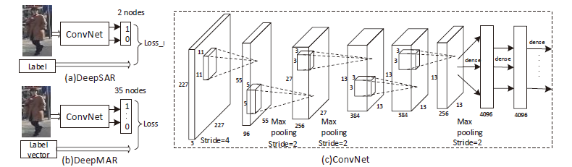

Figure DeepSAR and DeepMAR model

The Convnet in (c) is based on caffenet which is finetuned at the last layer to detect 35 attributes. This convent is a shared network between DeepSAR and DeepMAR as shown in (a) and (b). We will compare our proposed model with DeepMAR only.

It includes five convolutional layers and three full connective layers. ReLu neural units are applied after each layer. The max pooling layer and local normalization layer are added after the first two ReLu layers. There is also a max pooling layer after the fifth ReLu layer. In addition, the images are resized to 256 × 256 first. After that, they are randomly mirrored and cropped to 227 × 227 to add the training data. The initial learning rate used is 0.001 and weight decay is 0.005 in this experiment. The best accuracy for this model is 82.6%

* **Pedestrian Attribute Detection using CNN(ShallowMAR)[2]**

The ShallowMAR model also predicts 35 attributes. Many convolutional neural network architectures were tested and the best architecture is discussed below.

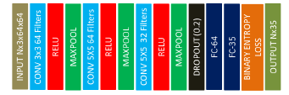

Figure ShallowMAR best model

ShallowMAR’s best model is where the first convolutional layer has 64 filters of size 3, the second convolutional layer has 64 filters of size 5 and the third convolutional layers has 32 filters of size 5. Each convolutional layer is followed by ReLU. The maxpool layers are of size 2x2 with stride 2. The last max pool layer is followed by a dropout layer where neurons are dropped at 20% probability, after which we have the fully connected layer that outputs the values for 35 attributes.

Adding more fully connected layers they increased the accuracy. And their best accuracy for ShallowMAR model is 81.3%.

# Chapter 3 Methodology

We will address the pedestrian attribute recognition problem as a multi label classification problem. We will design a multi attribute learning convolutional neural network model that explores the relationship between the attributes and predicts all the attributes at the same time. First let’s try to understand what multi label classification is and how we are going to perform the classification.

## Multi Label Classification

Multi label classification problems are the type of problems where we have a set of target labels. But what makes it different from a multi class classification problem is that, an instance can be assigned multiple labels from the set of target labels whereas in multi class classification problem an instance can be assigned a single label only from the set of target labels.

## Multi Label Classification problem transformation

We are going to use binary relevance technique to transform the problem. **Binary relevance** is the simplest technique which treats each label as a single class classification problem.

If we have n number of target labels, then the problem is broken into n different single class classification problems.

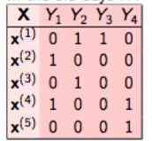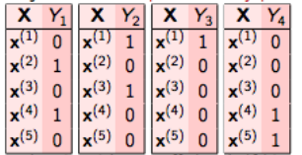

Figure Binary Relevance technique

## Data Preprocessing

### 3.3.1 PETA dataset

The far-view images dataset that we are going to use for training our model and detecting the attributes is PEdesTrian Attribute (PETA) dataset. PETA is a combination of 10 publicly available small scale datasets. PETA dataset is one of the biggest challenging dataset for benchmark evaluations. Because it consists of different datasets there are differences in illumination, viewpoint, scenes and resolutions of images

The PETA dataset consists of 19000 images, with resolution ranging from 17-by-39 to 169-by-365 pixels. Those 19000 images include 8705 persons, each annotated with 61 binary and 4 multi-class attributes.

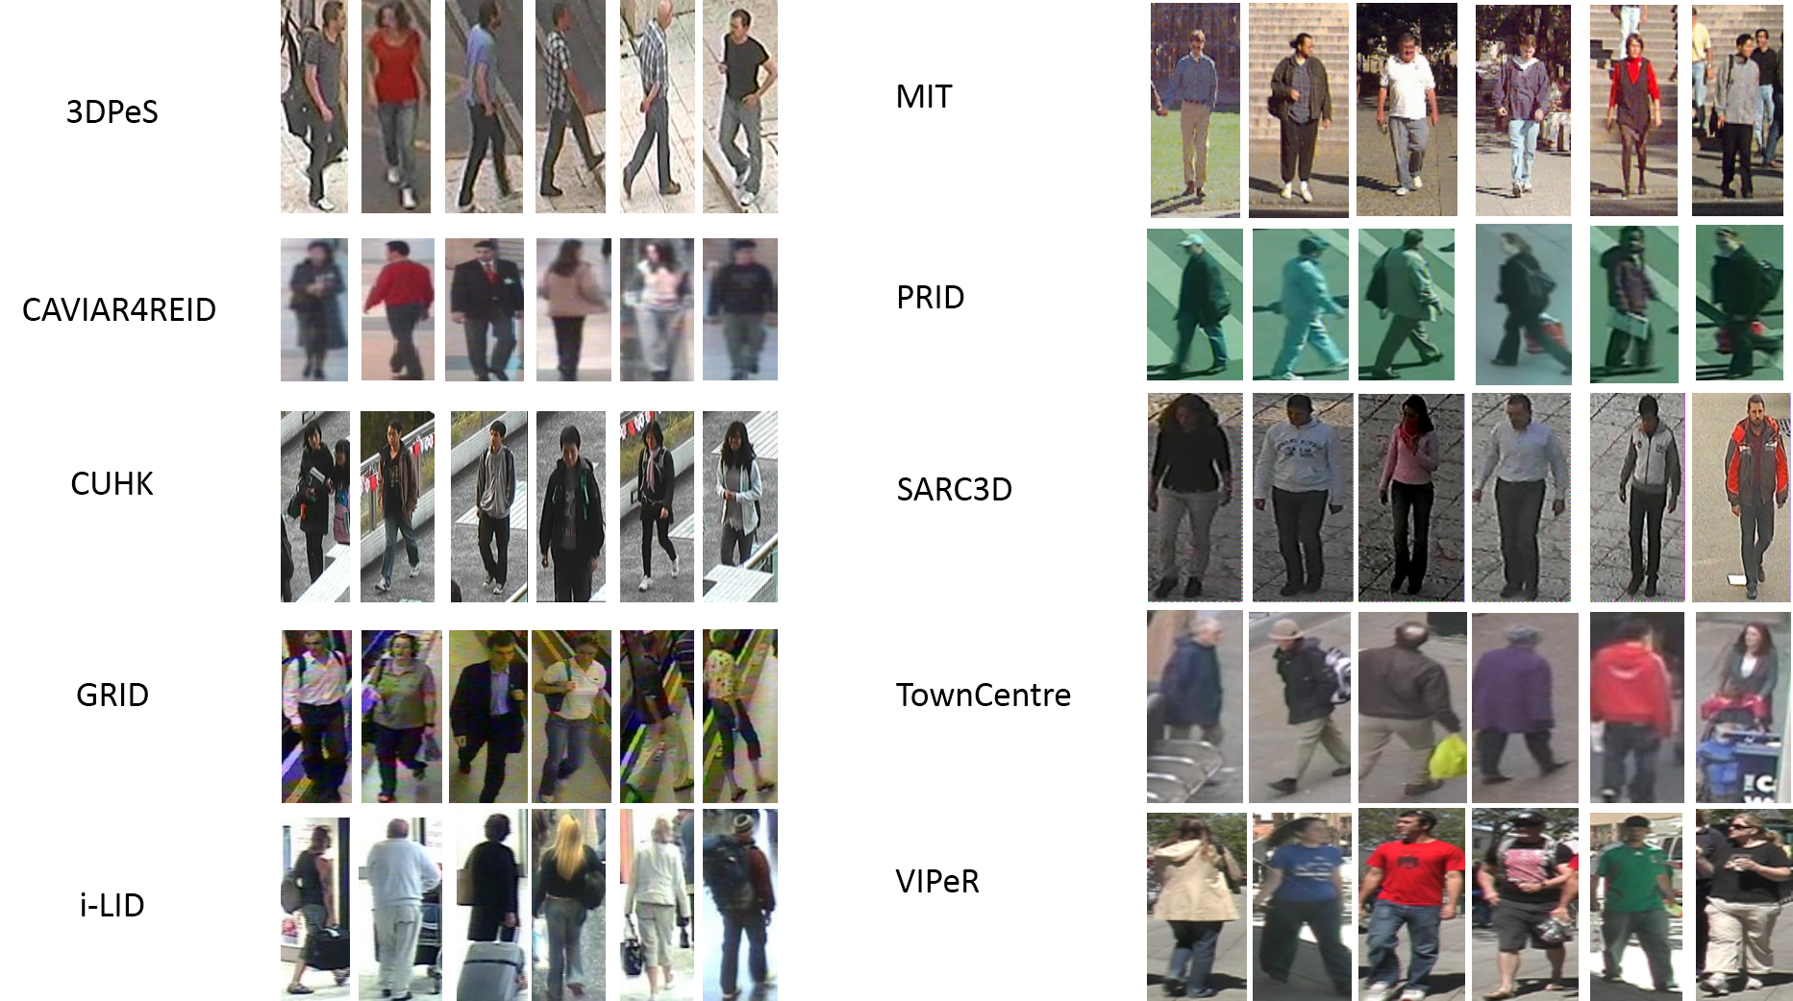

Figure Sample Images from 10 datasets that form PETA dataset

We chose 47 binary attributes from the 61 binary attributes. The selected 47 binary attributes are -

* **Accessory** – Hairband, Hat, Headphone, Handkerchief, Muffler, Nothing, Sunglasses
* **Carrying** – Backpack, Messenger Bag, Nothing, Other, Plastic Bags, Suitcase
* **Footwear** – Boots, Leather shoes, Sandals, Shoes, Sneakers, Stocking
* **Hair** – Bald, Long, Short
* **Lower body** – Capri, Casual, Formal, Hot pants, Jeans, Long skirt, Short skirt, Shorts, Trousers
* **Personal** – Female, AgeLarger 60, AgeLess15, AgeLess 30, AgeLess 45, AgeLess 60, Male
* **Upper body –** Casual, Formal, Jacket, Long Sleeve, Other, Plaid, Short Sleeve, Tshirt, Vneck

These attributes had more samples for training than the other ones which haven’t been selected. And most of them had also been selected in previous works using this dataset.

**PETA dataset URL**: <http://mmlab.ie.cuhk.edu.hk/projects/PETA.html>

[6]The dataset is officially available at the link above for research purpose only.

### 3.3.2 Downloaded Files Information

The PETA dataset was available as a zip file containing all the images of all datasets and label text files that contained the labels for corresponding images. But the images were arranged in 10 different folders for 10 datasets and 10 label text files in each folder for the respective images. So this required a lot of preprocessing steps to fix the labels and image files before using them.

### 3.3.3 Label and Image Files Preprocessing:

1. **Sort Labels**: Every line in the label text files started with the image ID of the image for which the following labels represented the attributes. But they were not sorted. So every label text files containing the labels were sorted according to Image ID by writing code for the task.
2. **Count Attribute Occurrences**: The number of times every attribute occurred in every dataset of the 10 datasets were counted from the 10 label files by writing code. It was needed to analyze which attribute was more present in images and for selection of the attributes.
3. **Handle Labels for Image ID Repetitions**: Many images of the same person from different viewpoint and angle had the same ID. But there was only a single line of label for that ID. To handle this repetition of IDs for different images, code was written to replicate the label lines for the images with same ID. The label lines in label text files were kept in the same order as the images in the folders.
4. **Rename Image Files**: Every image files in the folders for 10 datasets were renamed using code. A short form of the dataset name was added as a prefix to every image file names. For example – CAV0012.jpg for CAVIAR4REID dataset.

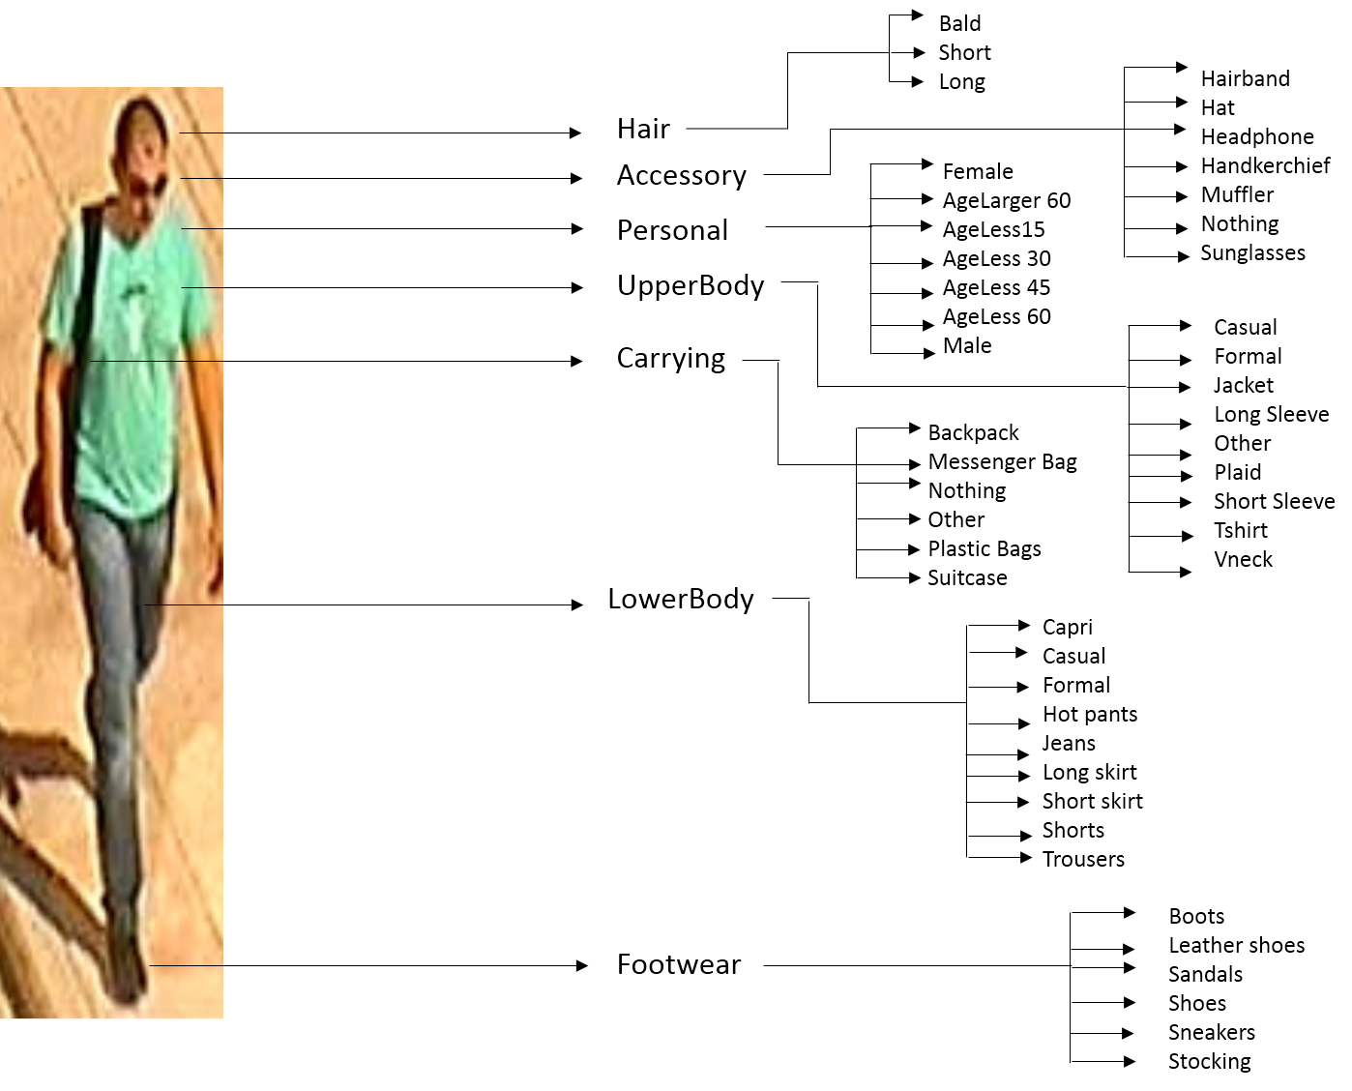

Figure Selected pedestrian attribute categories and subcategories

1. **Merge images and labels**: Every images from 10 folders could now be copied to one final folder as there’s a prefix to every image name of the dataset they belong to. And all the label lines from every label text files were now merged and copied into a single label text file. They were merged in the order of the images in the final folder.
2. **Create separate label files:** Separate label files are to be created from the final label text files. One file that contains labels with no IDs at the beginning of every line. Another label text file with headers of name of the datasets for double checking purpose.
3. **Eliminate attributes:** The labels for the attributes that were not selected are to be eliminated using code. 47 attribute labels will be left for all the images.
4. **Strip Newline:** When reading every label lines from the final label text file, the newline characters should be stripped from the end of every line to prevent extra labels from showing up.
5. **Multi One Hot Encoding:** One hot encoding is converting categorical Y values that have no particular order into a form that can be used for machine learning and deep learning algorithms. It arranges all the unique Y categories in dataset in separate columns and assigns 1 to the category which is present in the corresponding X value and 0 to the others.

Multi one hot encoding is required in this case, because it’s a multi label classification problem, 1 has to be assigned to multiple columns. There are total of 47 unique labels. They are multi one hot encoded for every corresponding X values, i.e. image values.

All of the above code for performing the image files and label files preprocessing tasks were written in python.

### 3.3.4 Image Preprocessing:

* **Image Resizing:** Resolutions of every images in the PETA dataset ranged from 17 by 39 to 165 by 369 pixels. For running the convolutional neural network, every image needs to have the same resolution. So they were all resized to 60 x 120 size. For images that had lesser resolution were scaled to the target size using LINEAR interpolation and for the ones with the higher resolutions, they were shrunk using AREA interpolation. These interpolation methods are the preferable ones for shrinking and zooming based on performance and speed.
* **Image Augmentation:** The bigger the dataset the better it is for the neural network to learn from. To increase the dataset for training, every images for training were flipped from right to left i.e. a horizontal flipping of the images were done to create new images. And they were added to the training image dataset.

## Proposed CNN Model

Now we will discuss about the proposed convolutional network architecture. It consists of three convolutional layers and two fully connected layers which use the extracted features from the previous convolutional layers and learn from it and thus performs the classification at the output layer. The proposed model was designed for predicting 47 selected attributes. For comparing with the DeepMAR[1],ShallowMAR[2] and MRFr2[8] model performances, the proposed model’s performance for 35 selected attributes was slightly better. The figure below shows the architecture of the proposed convolutional neural network

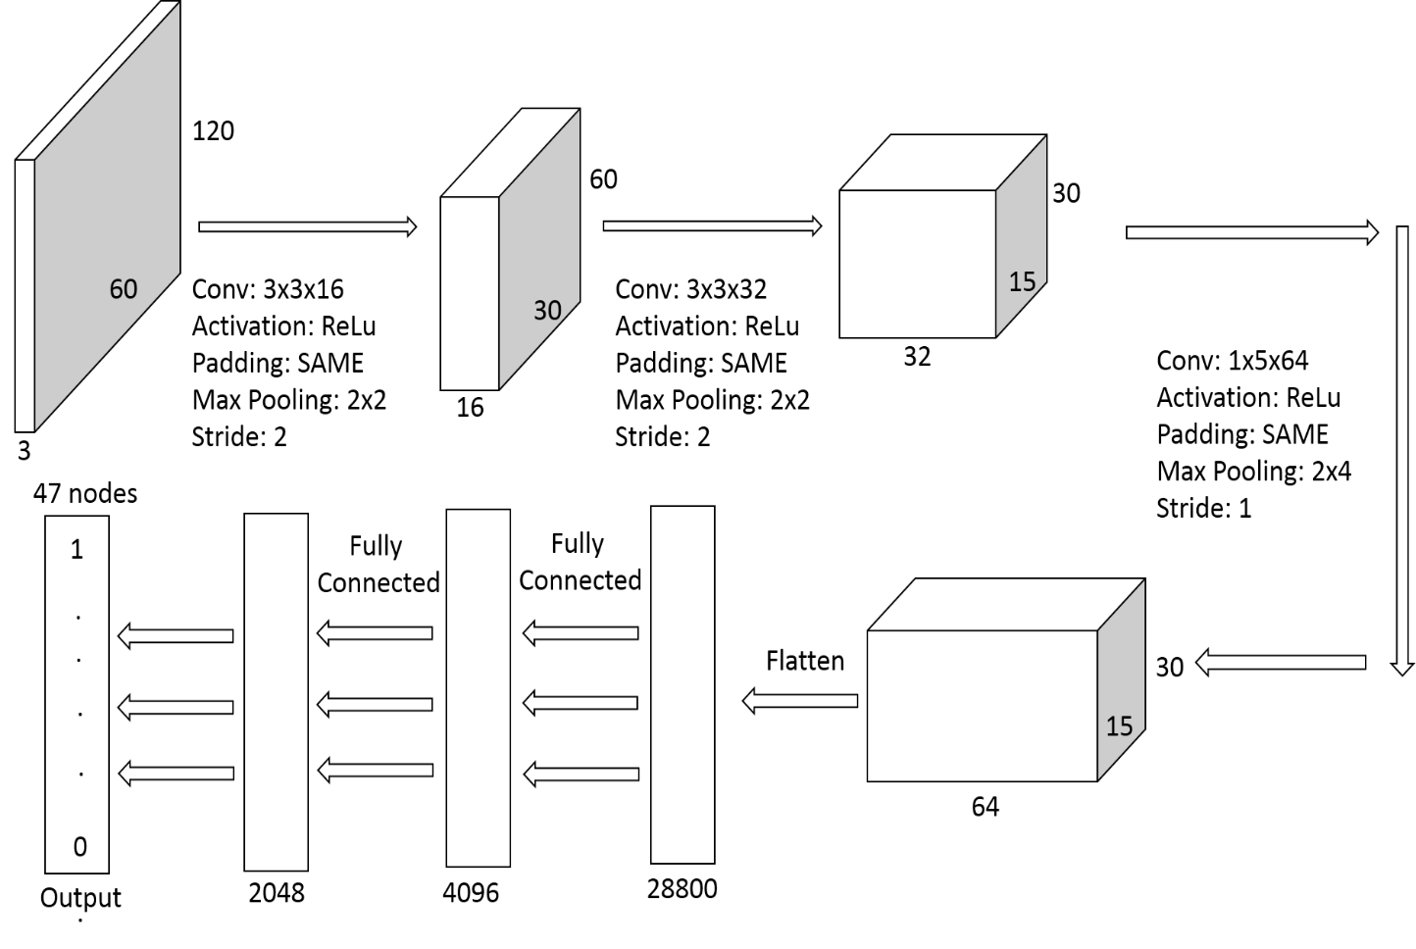

Figure Proposed convolutional neural network model architecture

Far view RGB images of pedestrians of size 60 x 120 with 3 channels will be input to this convolutional neural network model. And there will be a total of 47 nodes in the output layer for detecting 47 attributes.

**1st Conv Layer:** The first convolutional layer consists of 16 filters of size 3 x 3 and 3 channels each. Here SAME padding is used i.e. the input images are zero padded in such a way that the filters convolve over every pixel of the input image. For SAME padding the output image after convolution is the same as the input image. The 16 filters convolve the input images of size 60 x 120. Because of SAME padding, the output feature maps after convolution are of size 60 x 120 and 16 channels.

**ReLu:** The output feature map is run through a ReLU activation function to introduce non linearity. This activation function turns any negative value into zero. So it makes every value non negative.

**1st Max pool:** The max pooling filter is of size 2 x 2 and it is used to reduce the dimensionality of the feature maps. This max pooling filter moves by a stride of 2 and so the output after this is images of size 30 x 60 and 16 channels.

**2nd Conv Layer:** The second convolutional layer consists of 32 filters of size 3 x 3 and 16 channels each. Here SAME padding is also used. 32 filters convolve the input images of size 30 x 60 and the output feature maps after convolution are of size

30 x 120 and 32 channels.

**ReLu:** Relu activation function is also applied to the feature maps.

**2nd Max Pool:** Max pooling filter of size 2 x2 which moves by a stride of 2, performs max pooling operation on the feature maps and output after this are images of size 15 x 30 and 32 channels.

**3rd Conv Layer:** The 3rd convolutional layer is where things work a bit differently. Here the filters are of size 1 x 5. This is used for convolving the features from pedestrian images in a vertical manner as all the images are of vertically shown pedestrians. This non-symmetrical size of the filter helps in finding discriminative features from the pedestrian images to detect the attributes. SAME padding is also used here. So after convolution, the output future maps are of the size 15 x 30 and 64 channels.

**Relu:** Relu activation function is also applied to the output feature maps.

**3rd Max Pool:** This max pooling layer is also different from the previous ones. Here the max pool filter is of size 4 x 2 for the same purpose as the 3rd Conv. Layer. And it’s stride is 1 in order to fully extract important features as this is the last layer for extracting features. So the output feature maps will have the same size i.e. 15 x 30 and 64 channels.

**FC – 4096:** The result of the last pool layer is flattened into a vectorised form containing 28,800 elements (15 * 30 * 64) which is followed by a fully connected layer of 4096 neurons. Every element of the vector is fully connected to 4096 neurons of this layer. Fully connected layers are used to use the final features extracted from the previous convolution and pooling layers to classify the image into the respective classes in the output layer. These FC layers learn from the features.

**Dropout:** A dropout layer is used for dropping out of the neurons for preventing the model from overfitting to the training data. 40% dropout is used after many epochs.

**FC-2048:** Another fully connected layer is used to improve the learning and increase the accuracy of the prediction. This layer consists of 2048 neurons.

**Output Layer:** FC-2048 is fully connected to the output layer which consists of 47 nodes representing 47 pedestrian attributes. The attribute score for each of the attribute is then computed in the 47 nodes respectively.

This is how the proposed CNN model shall work with the far view images we provide to this model.

The third convolutional layer is specifically designed to work for the pedestrian attribute recognition task

* The convolutional filter is vertically oriented with a height of 5 and a width of 1 pixel to extract the features of the vertically oriented pedestrian images
* The max pooling filter has the same structure too for the same purpose with a height of 4 and a width of 2 pixels
* Most importantly, the max pooling filter has a stride of 1 which retains all the information for better learning of the features in the next fully connected layers

## Classification Loss Function

A loss function is used to measure the performance of a classification model whose output is a probability value. It can also be called a cost function. The loss function that we are going to use is cross entropy loss. In the context of machine learning a cross entropy loss and log loss can be considered the same. It measures the performance of a model whose output is a probability value between 0 and 1. The more the predicted value diverges from the actual value, the more the cross entropy loss becomes.

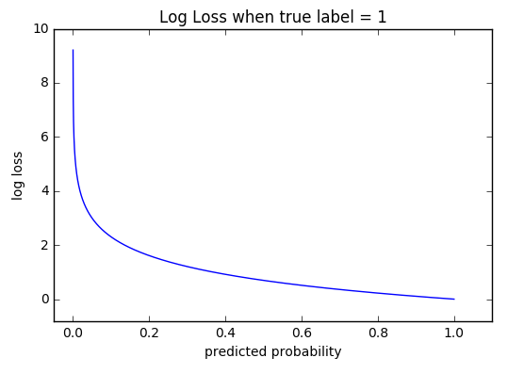

Figure Cross entropy loss curve

The mathematical formula for cross entropy loss for binary classification is –

|  |  |  |
| --- | --- | --- |
|  | $$Loss= -(y\left(\log\left(p\right)\right)+\left(1-y\right)log⁡(1-p)$$ | (1) |

Where log = natural log,

y = ground truth label [0 or 1]

p = predicted probability

Since our problem is a multi-label classification problem we will use sigmoid cross entropy loss as our loss function as this loss function considers all the attributes jointly.

|  |  |  |
| --- | --- | --- |
|  | $$Loss= \frac{-1}{N}\sum_{i=1}^{N}{\sum_{l=1}^{L}{\left(y_{il}\log\left(\hat{p_{il}}\right)+\left(1- y_{il}\right)\log\left(1-\hat{p_{il}} \right)\right)}}$$ | (2) |

|  |  |  |
| --- | --- | --- |
|  |  | (3) |

Here, the output probability $\hat{p_{il}}$ is run through a sigmoid activation function and then used in the final cross entropy loss formula 2. N is the number of pedestrian images and L is the number of attributes. $y_{il}$ is the ground truth label for $i∈1,..,N$ and $l ∈1,..,L$

## Optimization Algorithm

Optimization algorithms are used to minimize the loss function by adjusting the learnable parameters of the model. For a neural network, the weights and biases are the learnable parameters. So the optimization algorithms calculate and update the weights and biases with optimum values which influence the model’s learning process.

**Gradient Descent**

It is the most important technique for training neural networks and the foundation algorithm. Gradient descent is mainly about

* Finding the global minimum
* Controlling the variance
* Updating the model parameters
* Lead to convergence

The following formula updates the parameters –

|  |  |  |
| --- | --- | --- |
|  | $$θ= θ-η∇J(θ)$$ | (4) |

Where, $θ$ denotes parameters, $η$ denotes learning rate and $∇J(θ)$ denotes gradient of loss function $J(θ)$

We are going to discuss how gradient descent evolved using different strategies and why they were improved.

1. **Standard batch/vanilla gradient descent:** The standard method calculates the gradient for the whole dataset and updates the parameters only once. So convergence will get very slow for this.
2. **Stochastic gradient descent[15]:** This one updates parameter for every training examples. And so the update becomes very detailed which is good but also has its drawbacks. Due to the frequent updates, the parameter updates will have high variance which causes loss functions to fluctuate to different values. And so convergence can become complicated for this.
3. **Mini batch gradient descent[16]:** This method combines the best parts of both vanilla and stochastic gradient descent. It performs a parameter update for every mini batches of size n which contains n number of parameters. Thus, it reduces the high variance of the updates significantly.
4. **Momentum[18]:** Momentum is used to reduce the high variance oscillations. It fastens the learning process of SGD by moving along the right direction more and reducing the oscillation in the wrong direction less. The momentum term $'γ$’ makes all the difference. It gives the fraction of the update vector v(t-1) at previous step t-1 and is added with current gradient.

|  |  |  |
| --- | --- | --- |
|  | $$V\left(t\right)= (γV\left(t-1\right)+η∇J(θ))$$ | (5) |
|  | $$θ= θ-V(t)$$ | (6) |

Thus, this reduces unnecessary parameter updates.

1. **Nesterov accelerated gradient[17]:** A problem is faced because of momentum. The momentum can get very high at the minima and thus there is a possibility that the minima can be missed. So, an approximation of the next parameter position is used by calculating $θ-γV(t-1)$. And gradient with respect this value is used instead of the current one.

|  |  |  |
| --- | --- | --- |
|  | $$V\left(t\right)= γV\left(t-1\right)+η∇J(θ-γV\left(t-1\right))$$ | (7) |

|  |  |  |
| --- | --- | --- |
|  |  | (8) |

1. **Adagrad[19]**: This method and from this method onward focuses on the learning rate as there was only one learning rate for all update. So, learning rate can be adapted based on parameters. It is computed by basing on the past gradients for every parameter at time step t. Summation of the square of the past gradients is used here

|  |  |  |
| --- | --- | --- |
|  | $$θ= θ_{t,i}-\frac{η}{\sqrt{\sum_{r=1}^{t}{g_{r,i}^{2}}}}g_{t,i}$$ | (9) |

But, due to the summation at the denominator, the learning rate is always decaying and at one point, learning is stopped entirely. And the initial learning rate has to be set too.

1. **Adadelta[20]:** This method rectifies the problems faced with Adagrad by restricting the window of past gradients to a fixed size of w. A decaying average of past squared gradients is used.

|  |  |  |
| --- | --- | --- |
|  | $${E[g^{2}]}_{t}={γE[g^{2}]}_{t-1}+(1-γ){g^{2}}_{t}$$ | (10) |

|  |  |  |
| --- | --- | --- |
|  |  | (11) |

1. **Adam[13]:** Adam stands for adaptive moment estimation. This is the most modified technique so far which takes the best from Adagrad and Adadelta. It calculates the momentum for every parameter along with learning rate for every parameter

Adam works well in practice and performs better than other adaptive learning-method algorithms. It converges very fast and the learning speed of the model is quite fast and efficient and also it rectifies every problem that is faced in other optimization techniques such as –

* Decaying learning rate
* Slow convergence
* High variance in the parameter updates
* Fluctuating Loss function

What Adam does differently is that, it also stores the decaying average of past gradients along with that of the past squared gradients

|  |  |  |
| --- | --- | --- |
|  | $${m_{t}= β}_{1}m_{t-1}+(1-β_{1})g_{t}$$ | (12) |
|  | $${v_{t}=β}_{2}m_{t-1}+(1-β_{2})g_{t}^{2}$$ | (13) |

$β_{1}$ and $β_{2}$ are decay rates. $m_{t}$ and $v_{t}$ are first and second moment estimates.

|  |  |  |
| --- | --- | --- |
|  | $${\hat{m}}_{t}= \frac{m_{t}}{1-β_{1}^{t}}$$ | (14) |
|  | $${\hat{v}}_{t}= \frac{v_{t}}{1-β_{2}^{t}}$$ | (15) |

So, like adagrad and adadelta, the parameter updates are made for adam in the following way

|  |  |  |
| --- | --- | --- |
|  | $$θ_{t+1}= θ_{t}-\frac{η}{\sqrt{\hat{v_{t}}}+ϵ}{\hat{m}}_{t}$$ | (16) |

We will therefore use the Adam optimization algorithm for the learning process of our convolutional neural network for detecting pedestrian attributes from far view images.

# Chapter 4 Experiments and Results

## Dataset and experimental settings

As discussed in the data preprocessing section of chapter 3, the dataset that we are going to use to train and test our model is PETA dataset. It is indeed one of the most diverse and challenging datasets for learning pedestrian attributes from far view images as it is a combination of 10 different datasets of pedestrian far view images.

The PETA dataset consists of 19000 images, with resolution ranging from 17-by-39 to 169-by-365 pixels. Those 19000 images include 8705 persons, each annotated with 61 binary and 4 multi-class attributes.

47 binary attributes have been chosen for learning and they have been mentioned in the previous chapter. The model will also be run for learning 35 binary attributes that were chosen in DeepMAR[1], ShallowMAR[2] and MRFr2[8] models in order to compare the performance of the proposed model with theirs. It’s only standard to select the same target labels for comparison.

The dataset will be divided into 15200 images for training and 3800 images for testing. The mentioned data augmentation technique will be used for the training dataset and it will be doubled by 30400 images. So the 30400 images will be used for training the model and the trained model will be tested on 3800 images.

So we will run the model for 47 and 35 binary attributes separately and measure its performance.

## Experimental Tools and Environment

Starting from data and image preprocessing to training and testing the model and measuring it’s performance and comparing it with other model’s performance, we have used many tools, packages and development environments.

### 4.2.1 Programming Language

We performed all our programming in Python language. Python is the most popular language used for machine learning as it has the largest collection of packages for implementing machine learning algorithms and working with data. Python is the preferable language in this field also because it is very easy to learn and understand. For working with text, audio, image, for solving machine learning problem, for deep learning, for visualizing data, there are many packages and libraries for python and some of them are scikit, numpy, opencv, nltk, librosa, pandas, matplotlib, tensorflow, pytorch and so on.

### 4.2.2 Integrated Development Environments

* **Spyder IDE(Anaconda) :** Anaconda is a free and open source distribution of the Python and R programming languages for data science and machine learning related applications (large-scale data processing, predictive analytics, scientific computing), that aims to simplify package management and deployment. Spyder IDE comes with anaconda and it is an open source light-weight IDE that has many important features that was required. Some of them are –
* Code introspection, code completion, horizontal and vertical splitting in editor
* Python and IPython console workspace
* Documentation Viewer
* Variable Explorer

All our data and image preprocessing codes were run in Spyder IDE. The variable explorer in this IDE made analyzing the data and preprocessing it easier.

* **Google Colaboratory:** Google Colaboratory is a free cloud service and a research tool for data science. Google released it with the goal of making machine learning and research easier for every person eager to work in this field. It is basically a Jupyter notebook environment with no setup required. The following features makes it the easiest and the best for anyone to work with large datasets and large deep learning models that require high computational power –
* Google Colab is free and it provides a very powerful Nvidia K80 Tesla GPU to anyone with a google account
* The GPU can be used as a backend continuously for 12 hours
* Jupyter Notebooks can be shared with anyone without having to download or install anything
* It is specially tailored for working with deep learning libraries like Tensorflow, Keras and others.

### 4.2.3 Libraries

* **Tensorflow:** Tensorflow is an open source python library for high performance numerical computation, specifically designed for the operations required in large deep learning models. It was developed by Google. Computations can be done across a variety of platforms like CPU,GPU and TPU
* **Scikit-Learn:** It is a free machine learning library that is built on numpy, Scipy and matplotlib. It provides all the tools for working with data andfor performing data analysis and mining operations.
* **OpenCV:** OpenCV Python is a library for Python programming language that is used for solving image processing and computer vision problems. It contains many inbuilt functions that are aimed at realtime image processing operations.
* **Matplotlib:** Matplotlib is a python data visualization package used for analyzing data and calculations
* **Numpy:** Numpy stands for numeric Python. Numpy is a powerful Python package used for scientific computing. It used N-dimensional array objects which are called numpy arrays.

## Implementation Details

We evaluated the proposed model on the images of the PETA dataset using Tensorflow python library. It contained implemented methods for all the loss functions and optimizers we used.

* We used the Adam Optimization and Sigmoid Cross Entropy implementations of Tensorflow library for running the model on the PETA dataset.
* Zero Padding was applied to every convolutional and max pool layers.
* All the weights of convolutional and maxpool layers were initialized by random values from a normal distribution
* All the output categorical values were multi one hot encoded by Multi Label Binarizer class from Scikit-Learn library.
* Batch size of 100 images were used for every experimental runs
* A dropout layer is added between the two fully connected layers

The PETA dataset with 19000 images was split into 15200 images for training and 3800 images for testing. The training dataset was augmented and so we had 30400 images for training. The training of the model was done on augmented training dataset and then later tested on test dataset.

## 4.4 Performance Evaluation metric

We evaluated the performance of the model on the dataset by computing the –

* Mean recognition accuracy of each attribute for all pedestrian images
* Mean recognition accuracy of all attributes for all pedestrian images

Accuracy is the proportion of the correctly classified instances and the total number of instances.

|  |  |  |
| --- | --- | --- |
|  | $$Accuracy= \frac{Number of correctly identified instances}{Total number of instances}$$ | (17) |

## 4.5 Experimental Results

Before we finalized the proposed model, comprehensive experiments were done with several convolutional neural network architecture on the dataset. The changes that we experimented with the architecture of the network were on

* Number of filters in layers
* Filter size
* Max Pooling filter size and stride
* Number and size of Fully Connected Layers

The changes in Max pooling filter size and stride helped increase the performance. But the most changes were observed when we experimented with the fully connected layers at the end of the network and increased their number and size.

We see that adding more fully connected layers leads to an increase in learning for the model.

The following fully connected layer architecture changes shows the increase in accuracy on test dataset

Table : Test accuracy score for different fully connected layer architectures

|  |  |
| --- | --- |
| **FC layers** | **Test Accuracy(%)** |
| FC-1024 | 79.6 |
| FC-2048+FC-1024 | 80.8 |
| FC-4096+FC-2048 | 83.1 |

We ran the proposed model with different learning rates. Among them the following graphs show the curve of change in cost over number of epochs.

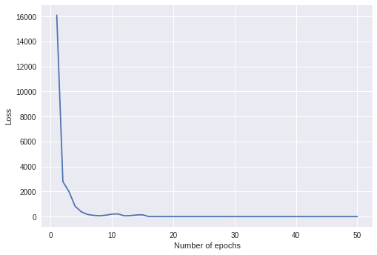

Figure Loss function curve for Learning rate 0.05

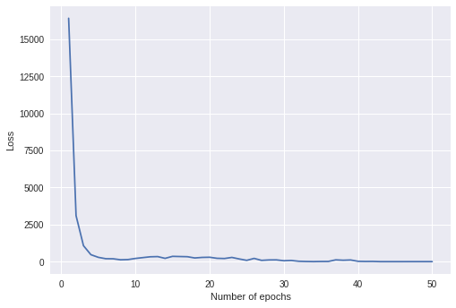

Figure Loss function curve for Learning rate 0.005

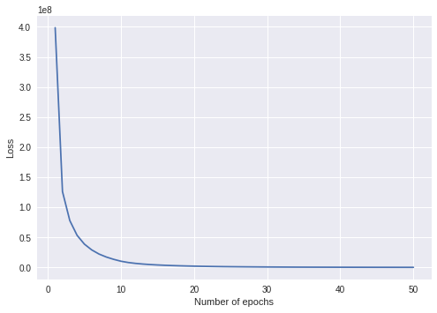

Figure Loss function curve for Learning rate 0.0005

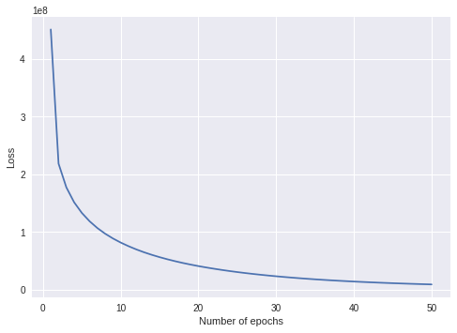

Figure Loss function curve for Learning rate 0.00005

We can see from the above graphs .0005 is the optimal learning rate and the proposed model gains the highest accuracy on test dataset with this learning rate.

Table : Attribute recognition accuracy score per attribute of proposed model for 47 attributes

|  |  |
| --- | --- |
| **Attribute** | **Proposed Model Acc.** |
| accessoryHairBand | 94.02 |
| accessoryHat | 92.68 |
| accessoryHeadphone | 99.47 |
| accessoryKerchief | 99.24 |
| accessoryMuffler | 94.24 |
| accessoryNothing | 80.23 |
| accessorySunglasses | 96.92 |
| carryingBackpack | 80.68 |
| carryingMessengerBag | 74.60 |
| carryingNothing | 71.47 |
| carryingOther | 70.43 |
| carryingPlasticBags | 92.15 |
| carryingSuitcase | 98.23 |
| footwearBoots | 95.16 |
| footwearLeatherShoes | 75.21 |
| footwearSandals | 96.68 |
| footwearShoes | 68.71 |
| footwearSneakers | 78.21 |
| footwearStocking | 95.36 |
| hairBald | 96.86 |
| hairLong | 79.21 |
| hairShort | 76.60 |
| lowerBodyCapri | 97.42 |
| lowerBodyCasual | 85.84 |
| lowerBodyFormal | 85.97 |
| lowerBodyHotPants | 98.84 |
| lowerBodyJeans | 73.02 |
| lowerBodyLongSkirt | 97.13 |
| lowerBodyShortSkirt | 92.97 |
| lowerBodyShorts | 94.97 |
| lowerBodyTrousers | 64.05 |
| personalFemale | 74.00 |
| personalLarger60 | 94.52 |
| personalLess15 | 98.73 |
| personalLess30 | 73.60 |
| personalLess45 | 71.02 |
| personalLess60 | 86.34 |
| personaMale | 73.95 |
| upperBodyCasual | 85.63 |
| upperBodyFormal | 87.94 |
| upperBodyJacket | 90.71 |
| upperBodyLongSleeve | 83.10 |
| upperBodyOther | 75.21 |
| upperBodyPlaid | 96.89 |
| upperBodyShortSleeve | 84.23 |
| upperBodyTshirt | 90.53 |
| upperBodyVneck | 98.24 |
| **Average** | **86.42** |

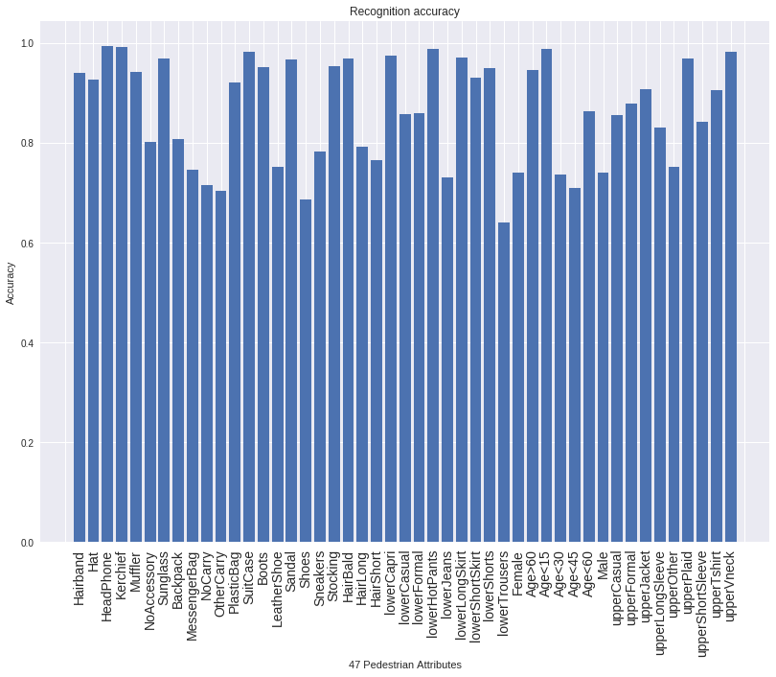

Figure Bar Graph for mean accuracy per attribute for proposed Model

The proposed model was run on the training dataset for a total of 100 epochs with learning rate of .0005. And 30% dropout was used after 80 epochs, which increased the mean accuracy from 85.7% to 86.4%. This is the best performance of the proposed model which predicts 47 pedestrian attributes at the same time.

Then we ran the model for 35 attributes for fair comparison with three of the models from previous works. (1) ShallowMAR – A popular CNN model for multilabel classification of pedestrian images 2) DeepMAR – Another popular CNN model for multilabel classification of pedestrian image and 3)MRFr2 – A Mark Random Field Graph which used the neighborhood information from multiple images and integrates foreground and whole image features to predict multiple pedestrian attributes. All of these models were evaluated on PETA dataset and they were used to predict these selected 35 attributes.

Table : Attribute recognition accuracy score of proposed model for 35 selected attributes and comparison with DeepMAR and MRFr2

|  |  |  |  |  |
| --- | --- | --- | --- | --- |
| Attribute | MRFr2(%)[8] | DeepMAR(%)[1] | ProposedModel(%) | Ratio (%) |
| Age16-30 | **86.8** | 85.8 | 72.15 | 45 |
| Age31-45 | **83.1** | 81.8 | 71.79 | 29 |
| Age46-60 | 80.1 | 86.3 | **88.84** | 9 |
| AgeAbove61 | 93.8 | 94.8 | **95.50** | 6 |
| Backpack | 70.5 | **82.6** | 79.53 | 17 |
| CarryingOther | 73.0 | **77.3** | 76.24 | 18 |
| Casual lower | 78.2 | 84.9 | **87.60** | 78 |
| Casual upper | 78.1 | 84.4 | **85.29** | 77 |
| Formal lower | 79.0 | 85.2 | **86.71** | 12 |
| Formal upper | 78.7 | 85.1 | **88.42** | 12 |
| Hat | 90.4 | **91.8** | 91.71 | 10 |
| Jacket | 72.2 | 79.2 | **92.02** | 6 |
| Jeans | 81.0 | **85.7** | 73.82 | 28 |
| Leather shoes | 87.2 | **87.3** | 78.84 | 26 |
| Logo | 52.7 | 68.4 | **97.07** | 3 |
| Long hair | 80.1 | **88.9** | 79.79 | 22 |
| Male | 86.5 | **89.9** | 72.50 | 49 |
| MessengerBag | 78.3 | **82** | 74.58 | 27 |
| Muffler | 93.7 | **96.1** | 94.24 | 8 |
| No accessory | 82.7 | **85.8** | 80.60 | 66 |
| No carrying | 76.5 | 83.1 | 74.26 | 24 |
| Plaid | 65.2 | 81.1 | **98.47** | 2 |
| Plastic bag | 81.3 | 87 | **90.45** | 6 |
| Sandals | 52.2 | 67.3 | **97.16** | 2 |
| Shoes | 78.4 | **80** | 67.95 | 33 |
| Shorts | 65.2 | 80.4 | **95.42** | 3 |
| ShortSleeve | 75.8 | 87.5 | 84.84 | 11 |
| Skirt | 69.6 | 82.2 | **96.29** | 4 |
| Sneakers | 75.0 | 78.7 | 78.02 | 19 |
| Stripes | 51.9 | 66.5 | **98.84** | 2 |
| Sunglasses | 53.5 | 69.9 | **96.47** | 3 |
| Trousers | 82.2 | 84.3 | 64.92 | 47 |
| Tshirt | 71.4 | 83 | **89.34** | 7 |
| UpperOther | 87.3 | 86.1 | 73.21 | 44 |
| V-Neck | 53.3 | 69.8 | **98.89** | 1 |
| **Average** | 75.6 | 82.6 | **84.91** | * |

The ratio mentioned in the table is the ratio number of attributes to the number of images in which they are present.

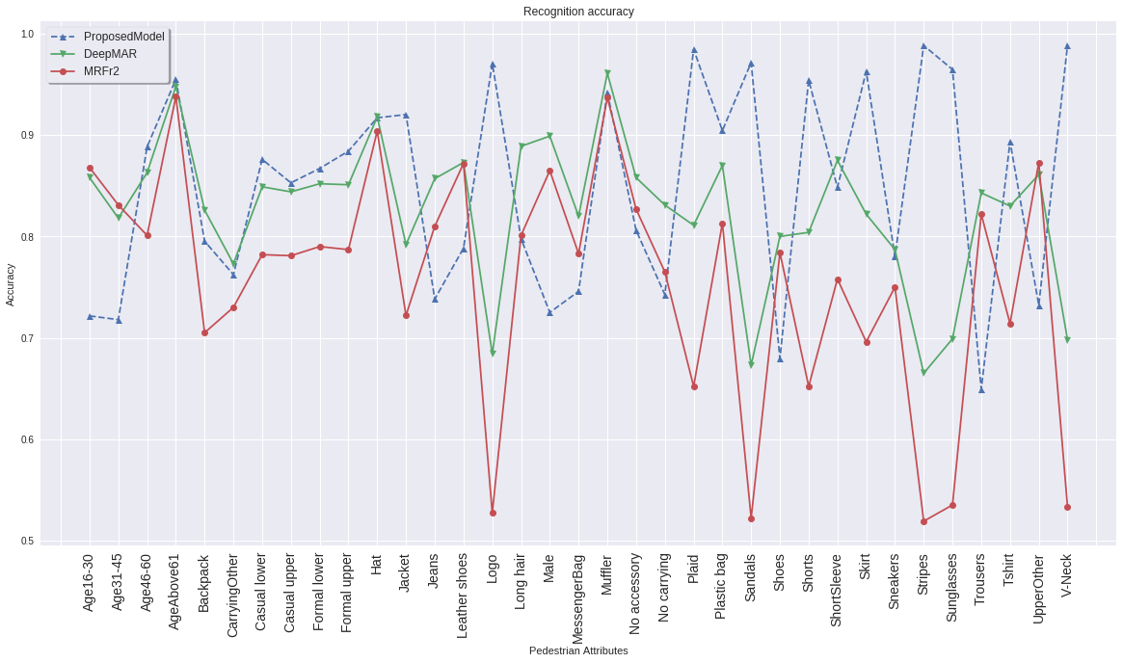

Figure Comparison of accuracies per attribute of different models

Here, X axis represents the attributes and they are sorted in the order as shown in table 3. The broken blue line represents the accuracy of our proposed model.

Table : Average Test Accuracy score for proposed model and other comparison models

|  |  |
| --- | --- |
| **Models** | **Average test Accuracy** |
| ShallowMAR[2] | 81.3 |
| DeepMAR[1] | 82.6 |
| MRFr2[8] | 75.6 |
| **Proposed Model** | **84.9** |

The third convolutional layer design was experimented with the conventional filter structures and none of them worked as well as the one in the proposed methodology. With the conventional max pool filter of 2 x 2 and Stride 2, the table below shows the accuracy ranges for the different conv. filter dimensions

**Table 5: Accuracies for conventional filter sizes for 3rd layer**

|  |  |
| --- | --- |
| **Conv. Filter Dimensions** | **Accuracy range** |
| 3x3 | 81.1-79.5 |
| 5x5 | 80.8-78.4 |
| 7x7 | 83.5-78.5 |

For 7x7 filter after 10-15 epochs all the predicted values were gibberish and they kept showing the same values, so the higher accuracy doesn’t mean much.

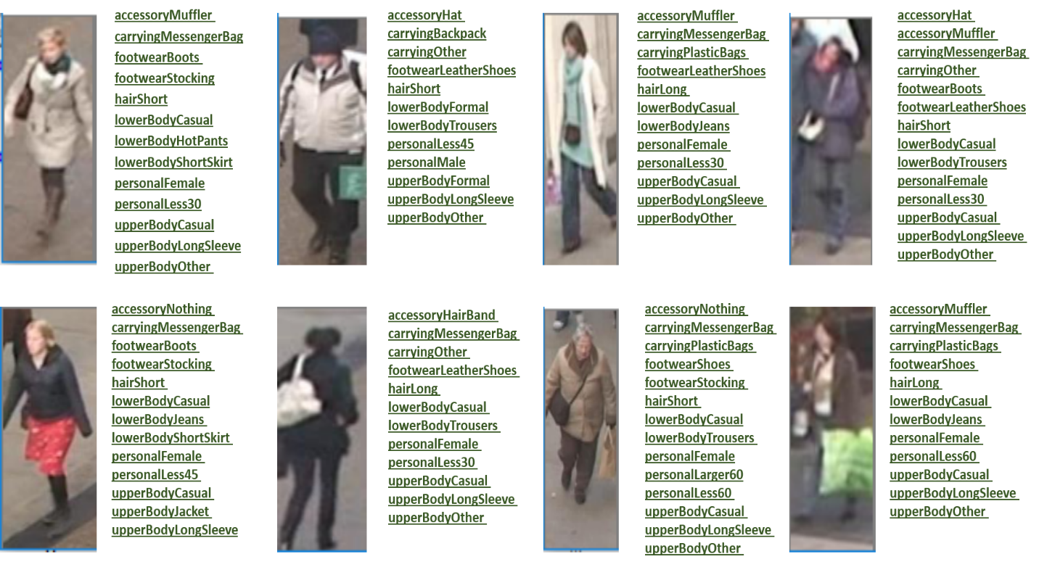

Figure Some samples of images with correct identification of every attributes

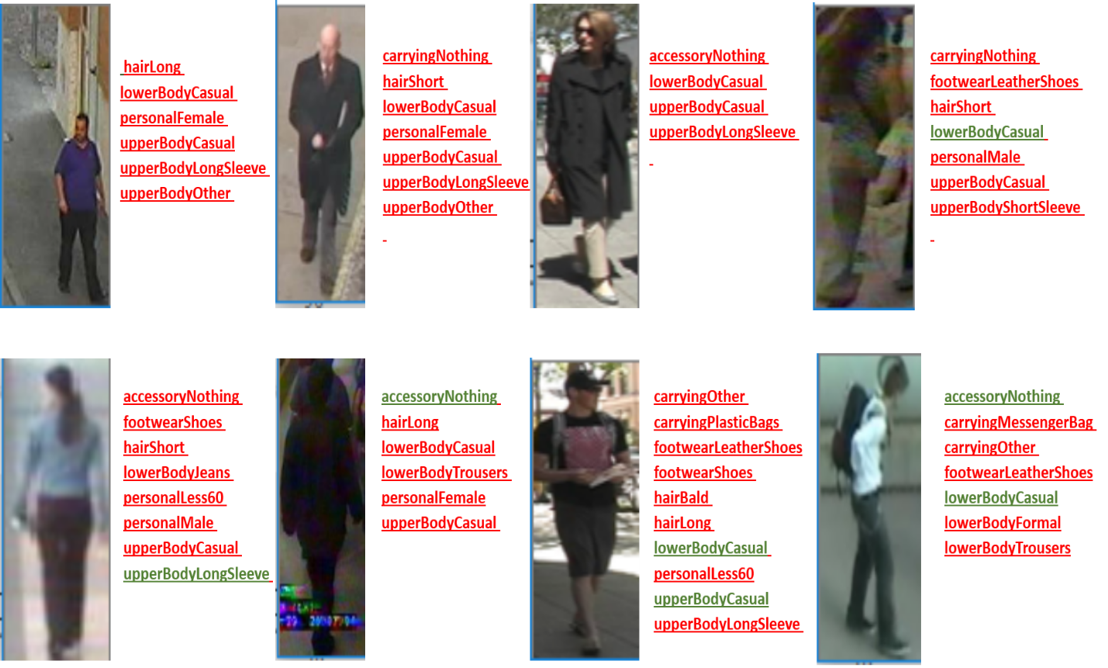

Figure Some samples with the most incorrect identification of attributes

## 4.6 Discussion

We have evaluated our model’s recognition accuracy for prediction the 47 selected attributes and 35 comparison attributes.

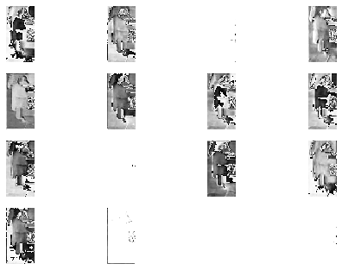

Figure Convolved images for 16 filters after first conv layer

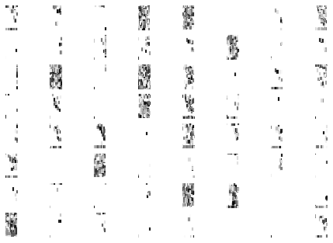

Figure Convolved images for 64 filters after final conv layer

### Model Results for 47 attributes

* The proposed model when run for predicting the 47 selected attributes achieves a mean recognition accuracy of 86.41%.
* It can accurately predict the all of the accessory attributes like Hat, Hair Band, Headphone, Muffler, Sunglasses with an accuracy from 90-99%.
* It can predict the carrying of plastic bags and suitcase with accuracies above 90%
* It has a good accuracy score for predicting hair of pedestrians. It can predict whether the pedestrian has bald hair more than whether it’s long or short.
* For casual and formal upper body and lower body clothing it gives a good accuracy score.
* For long and short skirt too, it gives good accuracy score
* For footwear it can successfully predict boots and sandals more than the others
* It gave an okay score in predicting of pedestrian genders. Gender prediction is a different field of research and it requires a more specific architecture.
* It gave bad accuracy scores for prediction of trousers and shoes

### Model results for 35 attributes and comparison

* Our proposed model’s mean recognition accuracy has outperformed the ShallowMAR, DeepMAR and MRFr2 model’s accuracy by 3.6%, 2.3% and 9.3% respectively
* Our proposed model has shown greater accuracy for 17 attributes out of 35 attributes. It has performed poorly in some compared to the models.
* Our proposed model gives an okay score for predicting backpack
* Proposed model has outperformed the other models with a big difference in the following attributes -
  + Jacket
  + Logo
  + Plaid
  + Skirt
  + Stripes
  + Sunglasses
  + Sandals
  + Formal and Casual
  + Vneck
* The proposed model has shown bad accuracy scores
  + Trousers
  + Shoes
  + Male Gender
  + Age 16-30 and Age 31-45

# Chapter 5 Conclusion and Future Work

## Conclusion

In this paper we have proposed a convolutional neural network model which addresses the pedestrian attribute recognition problem as a multi label classification problem. Our model has shown greater accuracy than the CNN models used for this problem. We have evaluated our model’s performance for prediction of 47 selected attributes and also for the 35 attributes previously worked with. Except for a few attributes, our model is effective in predicting many of the pedestrian attributes.

## Future Work

In future, we will work on using other loss functions and multi label classification methods and we will work on improving our CNN model for performing better in recognition of gender and age.

# References

1. Li, D., Chen, X. and Huang, K., 2015, November. Multi-attribute learning for pedestrian attribute recognition in surveillance scenarios. In Pattern Recognition (ACPR), 2015 3rd IAPR Asian Conference on (pp. 111-115). IEEE.
2. Gupta, A. and Ramesh, J., Pedestrian Attribute Detection using CNN.
3. Kurnianggoro, L. and Jo, K.H., 2017, October. Identification of pedestrian attributes using deep network. In Industrial Electronics Society, IECON 2017-43rd Annual Conference of the IEEE (pp. 8503-8507). IEEE.
4. Raza, M., Zonghai, C., Rehman, S.U., Zhenhua, G., Jikai, W. and Peng, B., 2017, May. Part-wise pedestrian gender recognition via deep convolutional neural networks. In 2nd IET International Conference on Biomedical Image and Signal Processing (ICBISP 2017) (pp. 1-6). IET.
5. Zhu, J., Liao, S., Yi, D., Lei, Z. and Li, S.Z., 2015, May. Multi-label cnn based pedestrian attribute learning for soft biometrics. In Biometrics (ICB), 2015 International Conference on (pp. 535-540). IEEE.
6. Deng, Y., Luo, P., Loy, C.C. and Tang, X., 2014, November. Pedestrian attribute recognition at far distance. In Proceedings of the 22nd ACM international conference on Multimedia (pp. 789-792). ACM.
7. Ahmed, E., Jones, M. and Marks, T.K., 2015. An improved deep learning architecture for person re-identification. In Proceedings of the IEEE Conference on Computer Vision and Pattern Recognition (pp. 3908-3916).
8. Deng, Y., Luo, P., Loy, C.C. and Tang, X., 2015. Learning to recognize pedestrian attribute. arXiv preprint arXiv:1501.00901.
9. Lin, Y., Zheng, L., Zheng, Z., Wu, Y. and Yang, Y., 2017. Improving person re-identification by attribute and identity learning. arXiv preprint arXiv:1703.07220.
10. Ji, Z., Zheng, W. and Pang, Y., 2017, September. Deep pedestrian attribute recognition based on LSTM. In Image Processing (ICIP), 2017 IEEE International Conference on (pp. 151-155). IEEE.
11. LeCun, Y., Bottou, L., Bengio, Y. and Haffner, P., 1998. Gradient-based learning applied to document recognition. Proceedings of the IEEE, 86(11), pp.2278-2324.
12. Krizhevsky, A., Sutskever, I. and Hinton, G.E., 2012. Imagenet classification with deep convolutional neural networks. In Advances in neural information processing systems (pp. 1097-1105).
13. Kingma, D.P. and Ba, J., 2014. Adam: A method for stochastic optimization. arXiv preprint arXiv:1412.6980.
14. Simonyan, K. and Zisserman, A., 2014. Very deep convolutional networks for large-scale image recognition. arXiv preprint arXiv:1409.1556.
15. Kiefer, J. and Wolfowitz, J., 1952. Stochastic estimation of the maximum of a regression function. The Annals of Mathematical Statistics, 23(3), pp.462-466.
16. Li, M., Zhang, T., Chen, Y. and Smola, A.J., 2014, August. Efficient mini-batch training for stochastic optimization. In Proceedings of the 20th ACM SIGKDD international conference on Knowledge discovery and data mining (pp. 661-670). ACM.
17. Nesterov, Y., 1983. A method for unconstrained convex minimization problem with the rate of convergence O (1/k^ 2). In Doklady AN USSR (Vol. 269, pp. 543-547).
18. Qian, N., 1999. On the momentum term in gradient descent learning algorithms. Neural networks, 12(1), pp.145-151.
19. Duchi, J., Hazan, E. and Singer, Y., 2011. Adaptive subgradient methods for online learning and stochastic optimization. Journal of Machine Learning Research, 12(Jul), pp.2121-2159.
20. Zeiler, M.D., 2012. ADADELTA: an adaptive learning rate method. arXiv preprint arXiv:1212.5701.
21. Layne, R., Hospedales, T.M., Gong, S. and Mary, Q., 2012, September. Person re-identification by attributes. In Bmvc (Vol. 2, No. 3, p. 8).
22. Zhu, J., Liao, S., Lei, Z., Yi, D. and Li, S., 2013. Pedestrian attribute classification in surveillance: Database and evaluation. In Proceedings of the IEEE International Conference on Computer Vision Workshops (pp. 331-338).
23. Chen, H., Gallagher, A. and Girod, B., 2012, October. Describing clothing by semantic attributes. In European conference on computer vision (pp. 609-623). Springer, Berlin, Heidelberg.
24. Collins, M., Zhang, J., Miller, P., Wang, H. and Zhou, H., 2010. EigenBody: analysis of body shape for gender from noisy images. In International machine vision and image processing conference.
25. Jaha, E.S. and Nixon, M.S., 2014, September. Soft biometrics for subject identification using clothing attributes. In Biometrics (IJCB), 2014 IEEE International Joint Conference on (pp. 1-6). IEEE.